To do this visualization I have selected **Tableau tool**. Tableau tool is most powerful, secured, and flexible end to end analytics platform for the data. Tableau is very easy to use interface, this helps the BI industry to analyze data. To visualize data there are few factors that influence the choices, which are audience, content, context, dynamics, and purpose. **Audience:** It’s important to adjust data representation to the target audience. **Content:** the type of data determines the tactics. **Context:** we may use different approaches to the way your graphs look and therefore read depending on the context. **Dynamics:** there are various types of data, and each of it implies a different rate of change. **Purpose:** the goal of data visualization also has serious influence on the way it is implemented.

For Hospital Management the main concentration is what vaccinations need to be reproduced to get that vaccines with less risk, reduce side effects and get cure for the patients to get that vaccine in time. Because the hospital management just need to know the demand of the medicine based on number of patients need to take the medicine for good health condition. To address the selected audience, my analysis of representing data in tree map. The use of this tree map is to display data in nested rectangles. Each rectangle has different size and color. So, I have considered few columns in the dataset to tell the story to the audience that are concentrated in the hospital managements point of view.

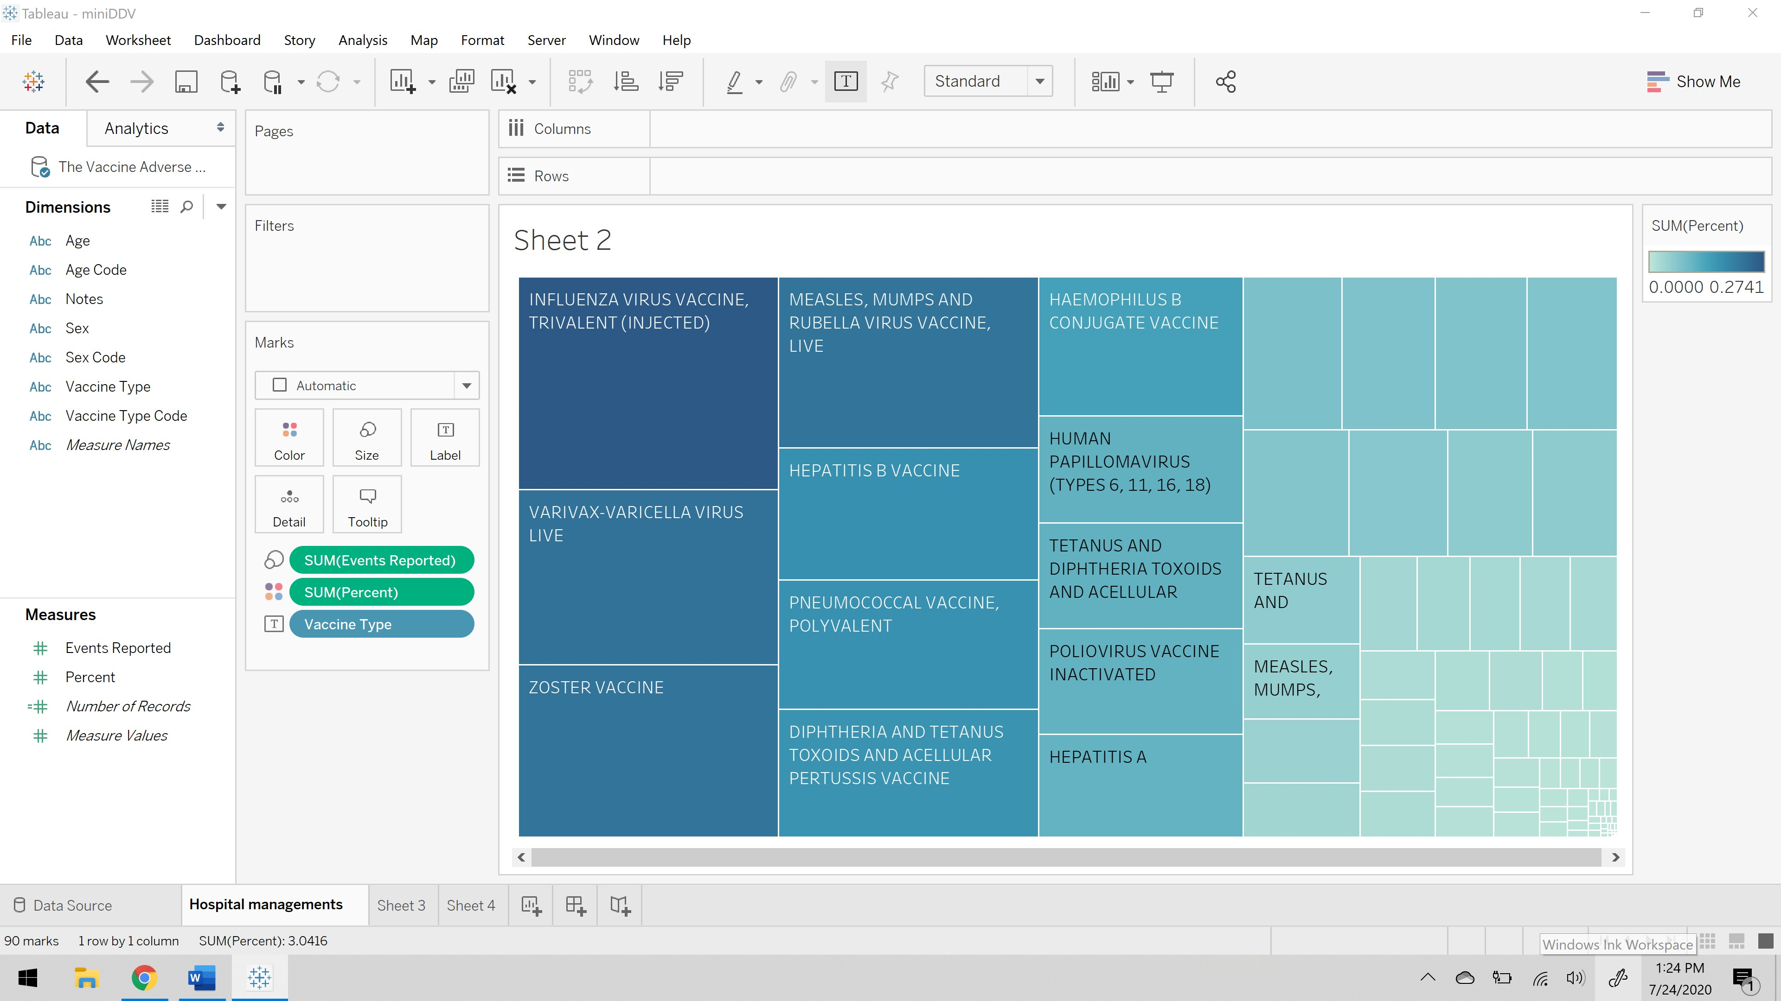

As you can see above visualization vaccines names as been placed on the label as you can see each rectangle is named as you hover on those rectangles. The size of each rectangle is defined by the events reported, which defines the complaints reported by the patients who has taken that vaccines. The color of each rectangle is defined by the percent, which is the risk exposure percentage. So, this visualization states a vaccine should be reconsidered to reduce the risk as per the hospital management’s perspective.

For healthcare workers interacting with families the main concentration of their story is to educate the patient for future side effects and talking through the facts based on the events reported in past. To enhancing the patient condition and preparing them for future as well. To address the selected audience, my analysis of representing data in stacked bars. This is an extended bar chart from looking at numeric values across one categorical variable to two. Each bar in a standard bar chart is divided into a few sub bars stacked on each categorical variable.

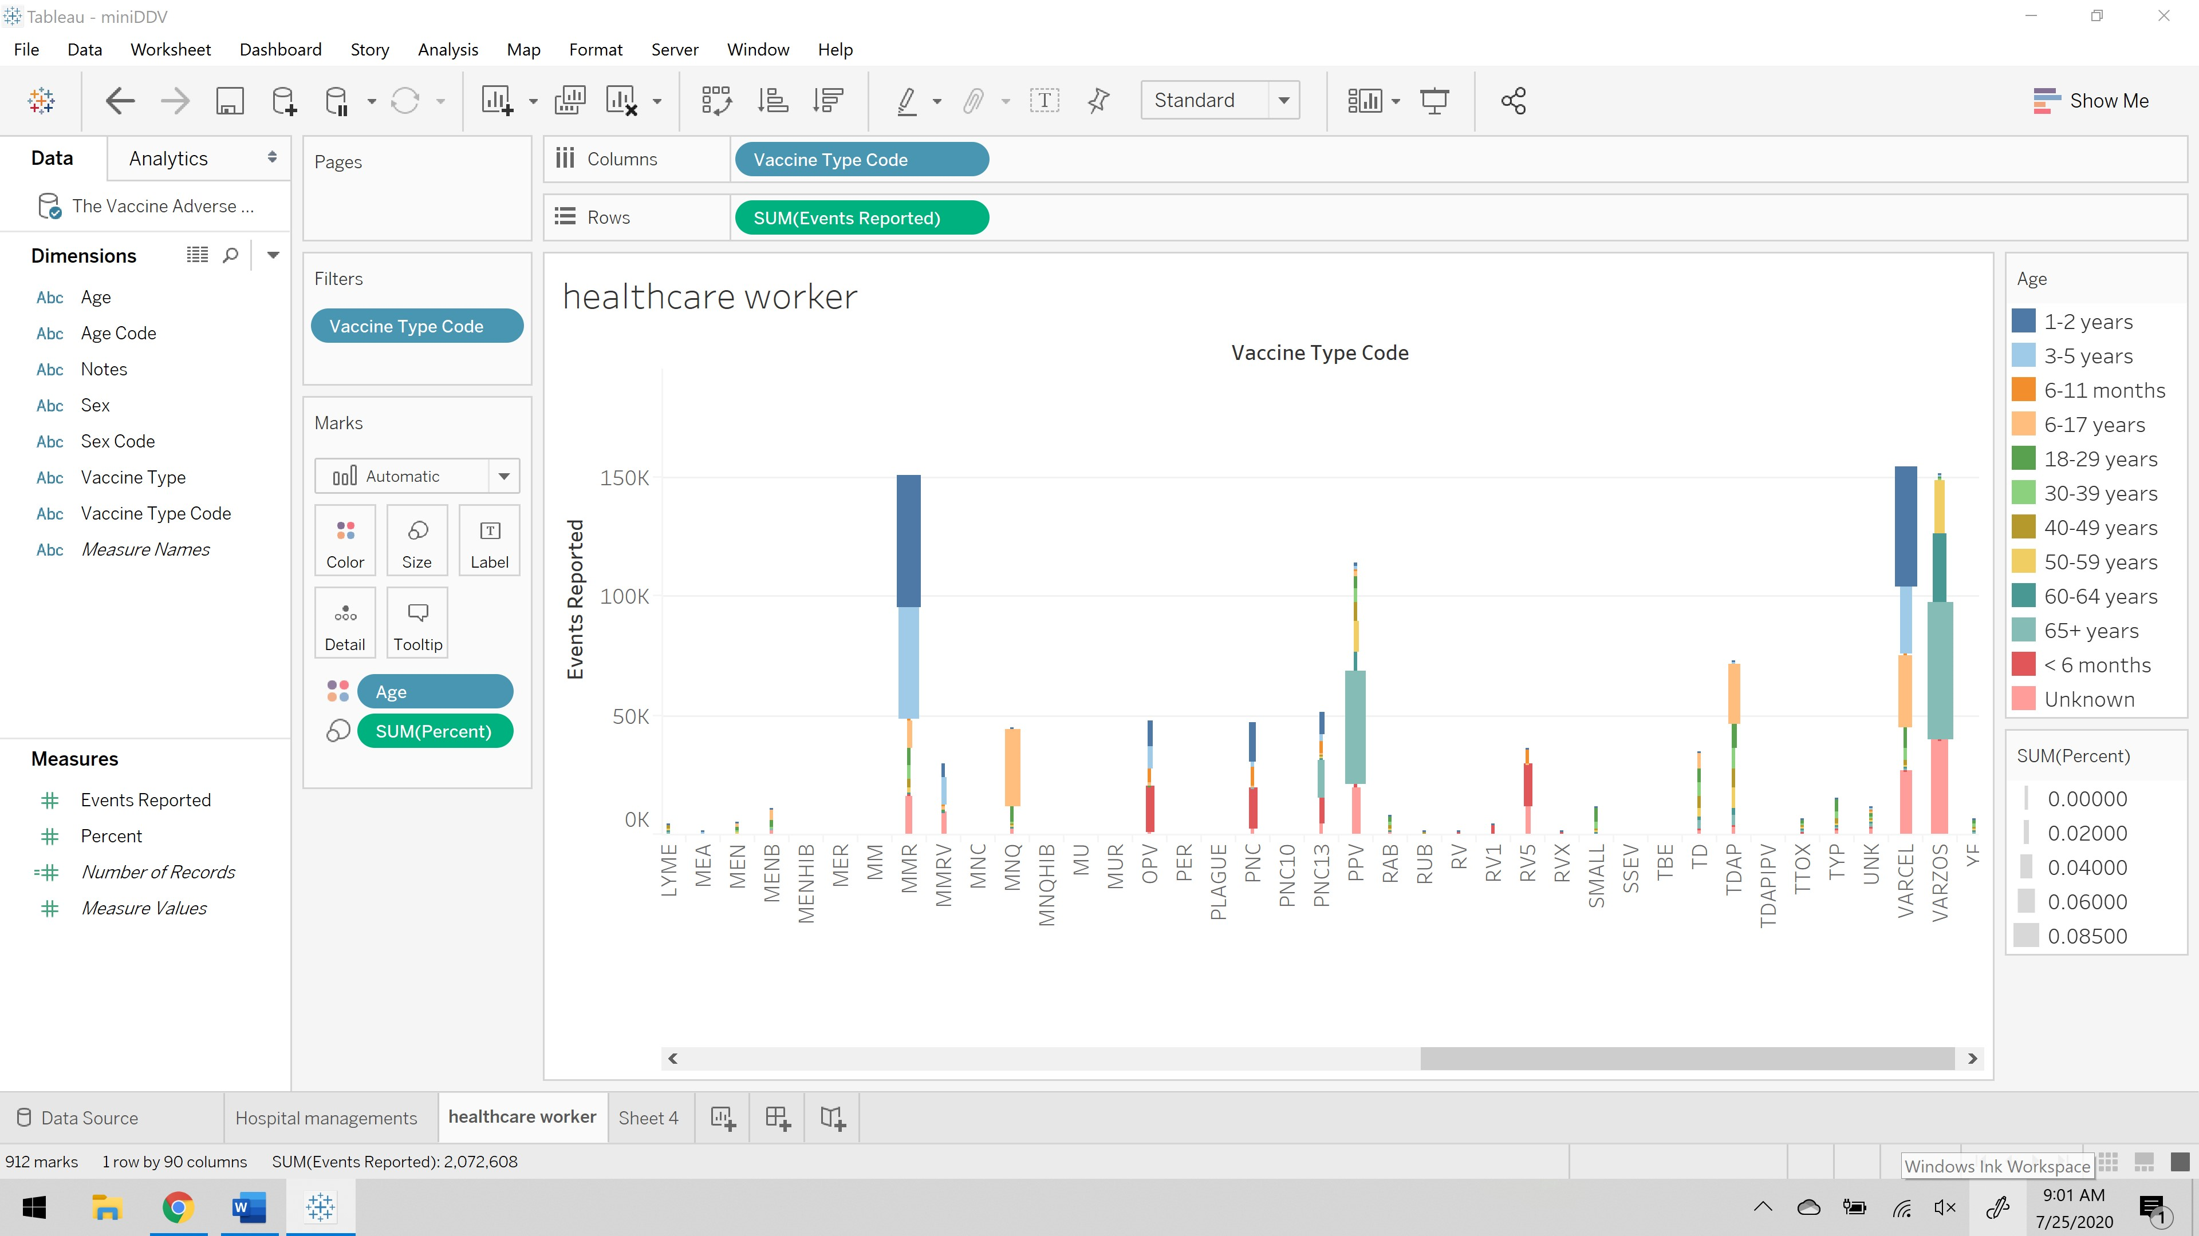

The above representation shows the color difference for age, the size of each bar is based on the risk percent, on x- axis there is vaccine type code and on y- axis there is events reported. This visualization gives us the information of how healthcare workers educate their patients regarding the vaccination and past events reported.

For the lay public audience are to be aware of what vaccination has highest risk percentage. Because the public just need to be aware of the vaccination that are available for the treatments if at all they need to have them what are the consequences. To address the selected audience, my analysis of representing data in Circle View chart. This is one of the powerful visualizations for comparative analysis.

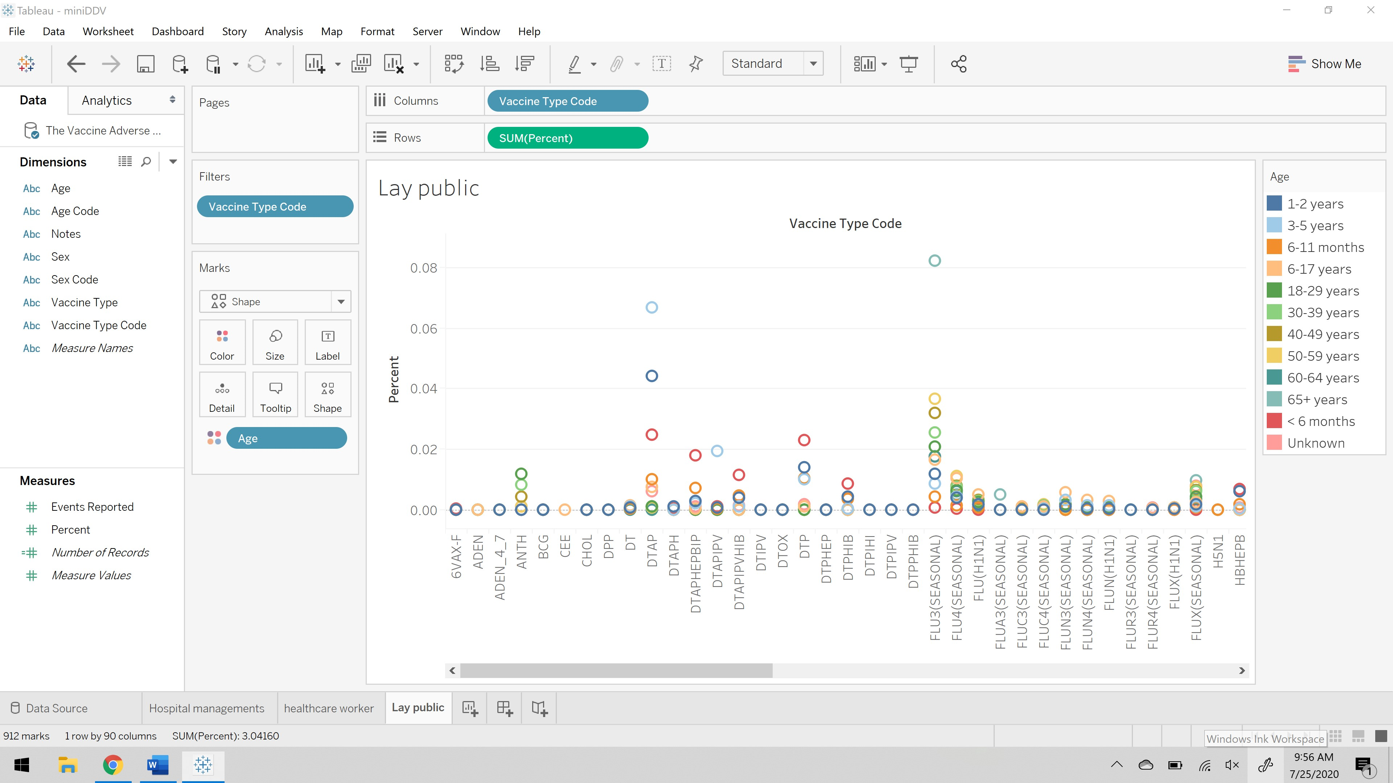

The above visualization shows the variation of color for age range, in x- axis there is list of vaccine type code, and in y- axis there is risk percentage. This visualization helps the public to figure out the what age group has the highest risk in taking that vaccine.

**Crafting a story:**

A lot of analysis is required to select how much and which content to be included in visualizing a data to present it to the audience. To do that the main goal is to shape a concise and coherent narrative around the data to compel the audience to take some sort of desired actions. To present the visualization we need to do the following steps:

1. **Creating an outline:** Identifying the tone of the visualization story that we need to convey to the audience. Selecting that data to support our point of view to make the audience understand the data that is presenting in the visualization.
2. **Arrange content in the most logical order:** Making the audience walk through the data in a logical flow. Each data visualization should help audience get closer to the narratives point of view.
3. **Provide context for the data:** Data visualization is meant to clarify, never confuse, or muddle. If there is a risk of misinterpretation, provide context to fill in the gaps.
4. **Highlight notable insights:** Although viewers can follow the data, key points may need more attention.
5. **Trim where necessary:** Do not overload with the data. Only include the data that is necessary and relevant to draw the audience towards the desired conclusion.

**Effective Feedback Mechanism:**

A Feedback Loop is the part of a system in which some portion or all the system’s output is used for future operations. Each feedback loop has a minimum of four stages. During stage one, input is created. Next on stage two, input is captured and stored. Later on stage three, input is analyzed and finally in the fourth stage, the insight gained from analysis is used to make decisions.

**References:**

1. <http://cdn2.hubspot.net/hub/53/file-2036439636-pdf/How_to_Use_Data_Visualization_to_Win_Over_Your_Audience.pdf>
2. <https://www.digiteum.com/data-visualization-techniques-tools>
3. <https://searchitchannel.techtarget.com/definition/feedback-loop#:~:text=A%20feedback%20loop%20is%20the,a%20minimum%20of%20four%20stages.>